- Interfacing Arduino with pot and servo motor
#include <Servo.h>
Servo myServo;
int potPin = A0;
int servoPin = 9;
int potValue;
int angle;
void setup() {
myServo.attach(servoPin);
}
void loop() {
potValue = analogRead(potPin); // Read potentiometer (0–1023)
angle = map(potValue, 0, 1023, 0, 180); // Convert to angle (0–180)
myServo.write(angle); // Move servo
delay(15); // Small delay for smooth movement
}
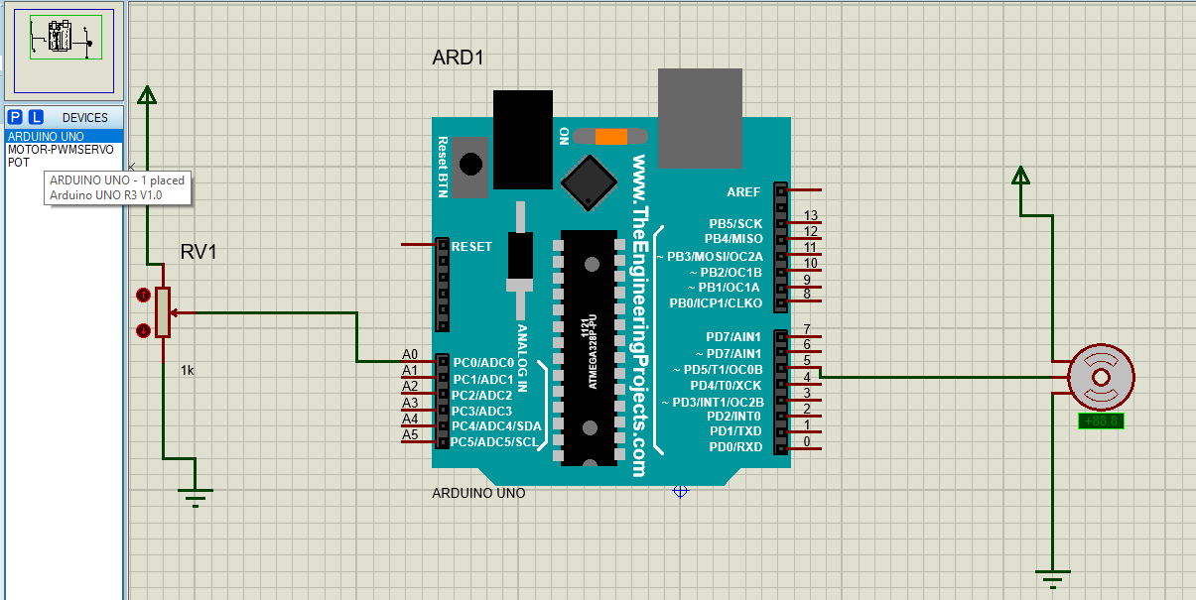
- Interfacing Arduino with stepper motor
#include <Stepper.h>
Const int apr = 40
Stepper motor(apr, 8, 9, 10, 11); // steps, pins
void setup() {
motor.setSpeed(10); // set speed
}
void loop() {
motor.step(apr); // move forward
delay(1000);
motor.step(-apr); // move backward
delay(1000);
}
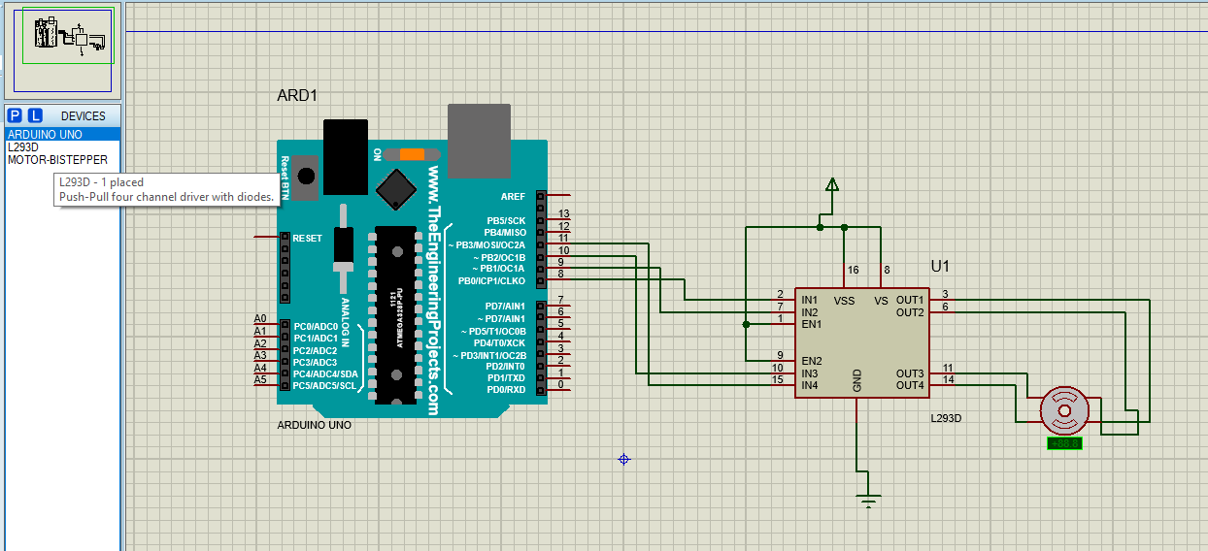

Interfacing Arduino with analog sensor – control led basd on ldr
int ldrValue;
void setup() {
pinMode(10, OUTPUT);
pinMode(11, OUTPUT);
}
void loop() {
ldrValue = analogRead(A0);
if (ldrValue < 500) {
digitalWrite(10, HIGH); // LED 1 ON
digitalWrite(11, LOW); // LED 2 OFF
} else {
digitalWrite(10, LOW); // LED 1 OFF
digitalWrite(11, HIGH); // LED 2 ON
}
delay(200);
}
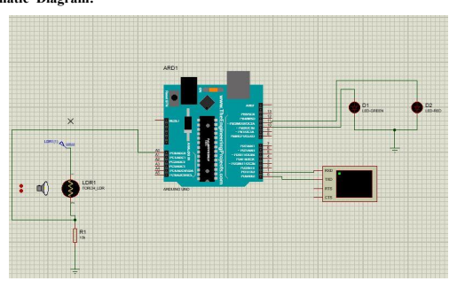

6. Interfacing DHT22 Sensor with Arduino
#include <DHT.h>
#include <LiquidCrystal.h>
LiquidCrystal lcd(12, 11, 5, 4, 3, 2);
DHT dht(13, DHT11);
void setup() {
lcd.begin(16, 2);
dht.begin();
}
void loop() {
float t = dht.readTemperature();
float h = dht.readHumidity();
lcd.setCursor(0, 0);
lcd.print("Temp: ");
lcd.print(t);
lcd.print("C");
lcd.setCursor(0, 1);
lcd.print("Hum: ");
lcd.print(h);
lcd.print("%");
delay(1000);}
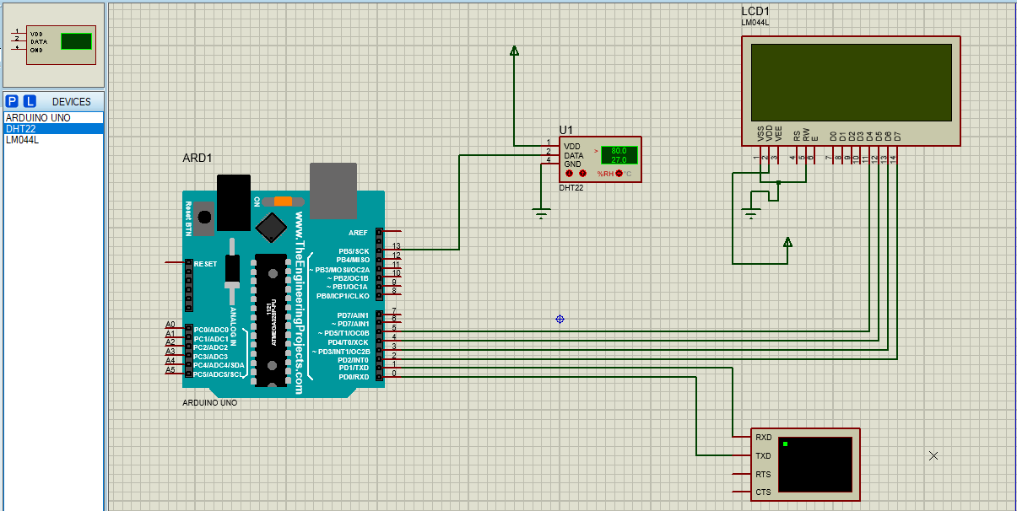

4 Write a program to interface LED/Buzzer with Arduino and to turn ON LED for 1 second after every 2 seconds.
const int LED=10;
void setup()
{
pinMode(LED,OUTPUT);
}
void loop()
{
digitalWrite(LED,HIGH);
delay(1000);
digitalWrite(LED,LOW);
delay(2000);
}

